**Instructions for Summer School General Ed Summer School/ESY**

[**Summer School Timecard Link**](https://app.informedk12.com/link_campaigns/2023-2024-summer-school-card?token=tyEd78GyPqSBmoD4xnWpfQ2m)

**Overview:**

**Summer School timecards are for general ed summer school employees. Food service will continue to use their normal ecards. Sp. Ed has instructions for the Sp. Ed time cards.**

**For the classified employees who are on contract during the year, and you work the day before OR after June 19, 2023 and July 4, 2023. You must add the holiday to your ecard. Substitutes are not on contract and not eligible.**

**Summer cards will be submitted twice during the summer for the following pay periods.**

**June 20, 2023 to June 30, 2023 must be submitted to your summer principal on July 3, 2023. This will be paid on July 14th. This payroll will have direct deposit for those who have it set up. Paper checks will be mailed to the home address we have on file.**

**July 1, 2023 to July 25, 2023 must be submitted to your summer principal on July 25, 2023. This will be paid on August 16, 2023. This payroll will have direct deposit for those who have it set up. Paper checks will be mailed to the home address we have on file.**

**All time will be submitted to your summer principal who will send it to Lyn Potter.**

**How to Complete the Timecard:**

When you click on the electronic timecard link, you will be directed to the form below. Fill out your *full legal name* and *district email*. Select ‘**Go to form**’

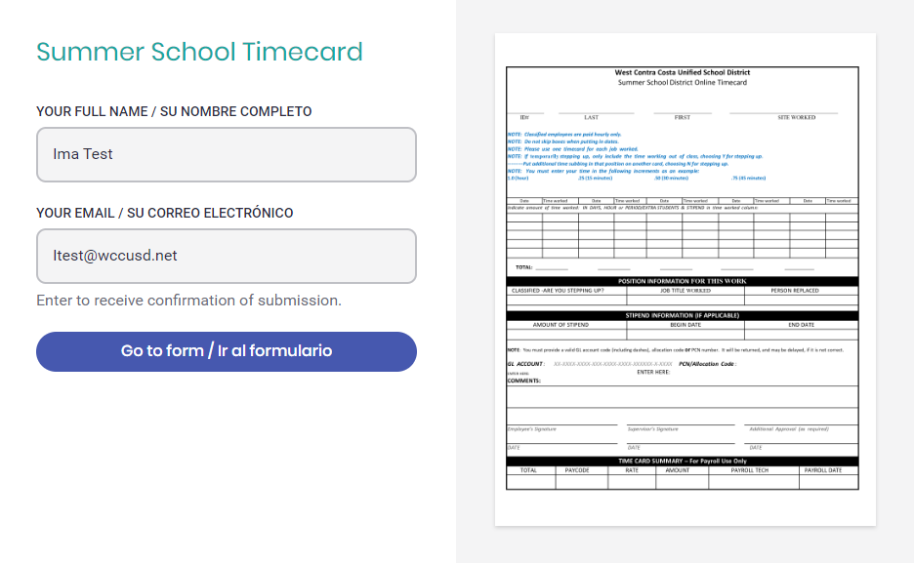

**Fill in** your *ID, LEGAL Last/First name* (Do not put any nicknames or middle names you go by), **Select the Site/Department** where the work you completed was done from the drop down menu. Don’t put where you normally work, if different. Put where the summer work was completed.

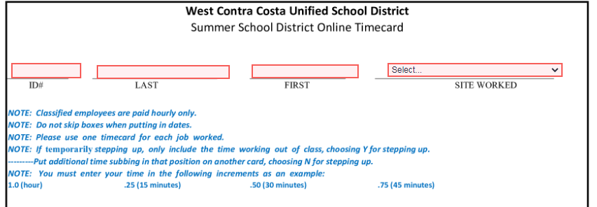

Click on the select button (red circle below) to choose Hour or Stipend if you are an administrator.

Click the date box (red box/arrow below) and either type the date or choose on the calendar that pops up.

Click the number box (blue box/arrow) and put in how many units you chose.

Please refer to the units (green box below) for hour to unit conversion. For example, if you worked 1 hour and 30 minutes, you will select hours and type in **1.5** for time worked. No need to leave any blanks boxes to match any calendar.

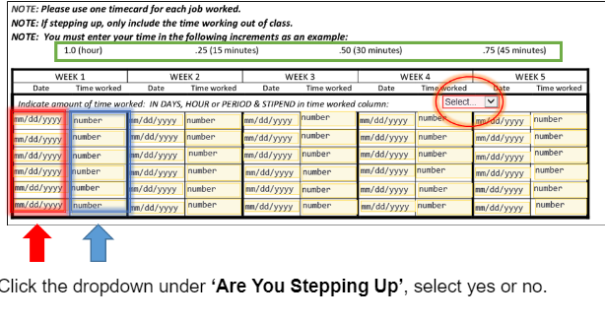

**Most summer employees are not stepping up into a higher position temporarily. Make sure you put in the job description what position you are to be paid. Only put in your normal position, unless you are doing the same job.**

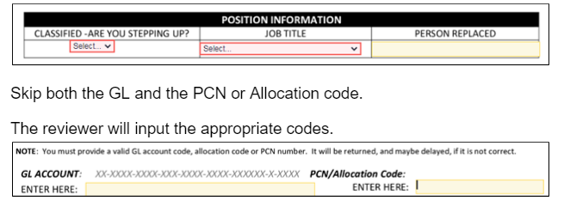

**Make any notes in the comments box. Please write where the summer program occurred. For example, Nystrom Summer Program.**

**Click on ‘Click to sign here’ to add your signature to your time card.**

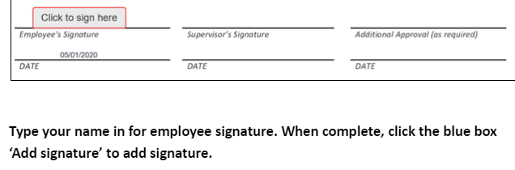

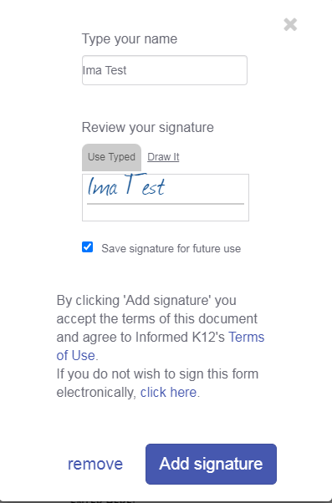

**Submit your timecard by clicking the ‘Submit form’ box.**



**Next to ‘Account Code Review’ click the ‘Select recipient’ box to send your time card to the appropriate account code reviewer.**

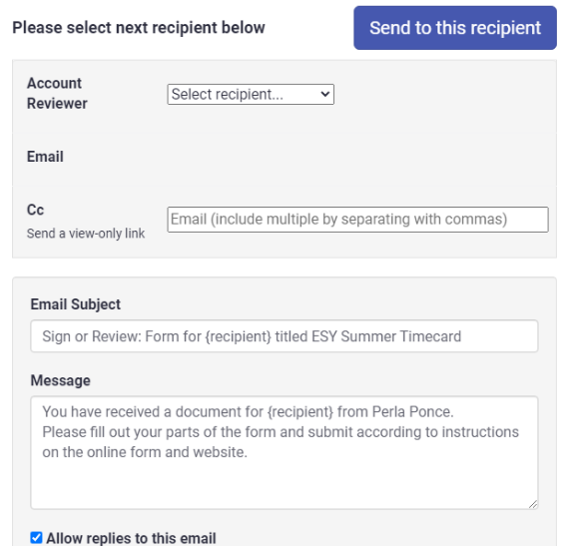

**You will choose the summer school position you are working. Your principal will send it to Dept - State & Federal for coding and approval.**

